1. **List out 5 files in your system which consuming most of the disk space.**

Ans:

* Used the **find** command to find and **–type** to find the files types present in the system.
* The **–exec** command is used to execute the following condition.
* Used **du** for getting the Disk Usage by following files.
* For getting 5 files consuming most space, sorted the list in reversed way by using **sort –rh** and at the last to get top 5 results used **head –n 5**.

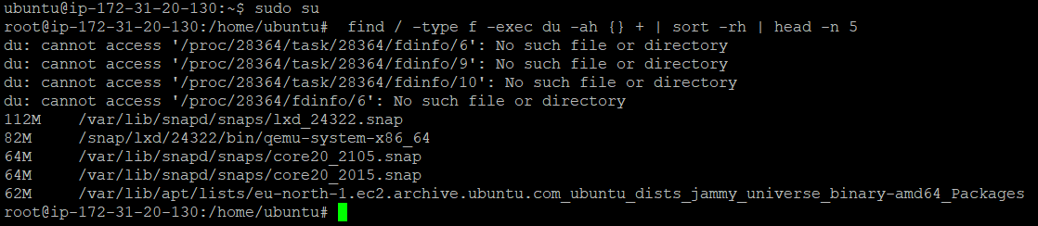

1. **Create one common folder in such a way that anyone can create files inside that independently and should not be able to delete other users files from that common folder.**

Ans:

* Created a common folder using **mkdir** and set **sticky bit** on it so that other users can’t delete files which they don’t own.

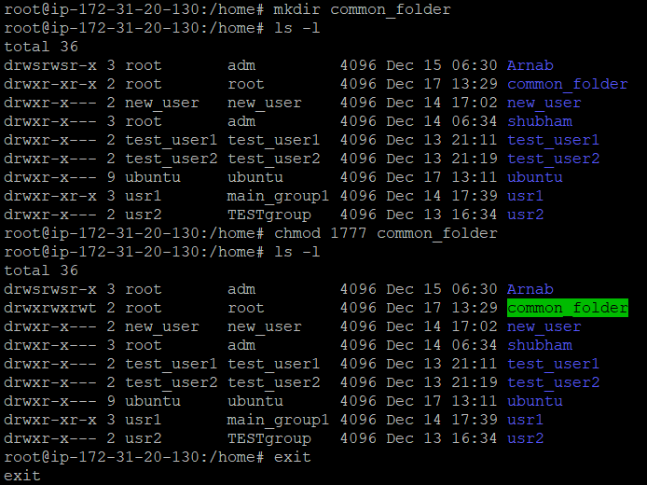

* Created a file using **touch** inside common_folder by ubuntu.

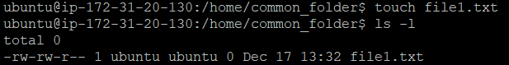

* Logined by another user Arnab and created another file2. We can clearly see that Arnab can’t delete (using **rm** command) but can delete file created by own.

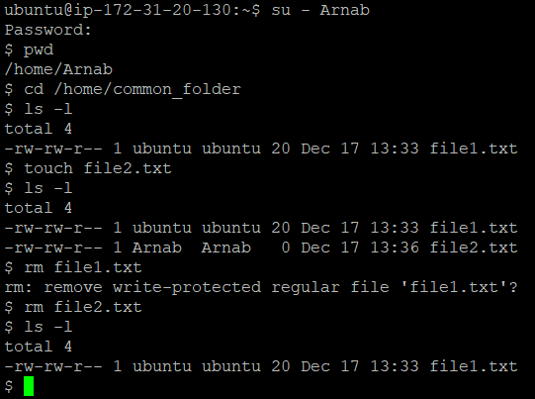

**3) Create user name "shubham" and add that user in the group "adm"  
      a) Create folder /data , change owner and group as  "root:adm  
      b) Change /data permission such a way that user can able to write data in this folder and ownership of files or folder which you creates in this folder should be same as parent folder i.e /data folder permission (root:adm)**

Ans:

* Created a user called “shubham” using **useradd** and **–m** is to create the user’s home directory.

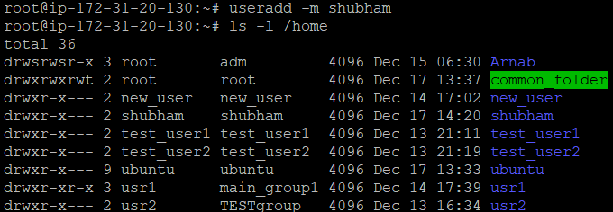

* To add shubham in group “adm”, I used **chgrp** command.

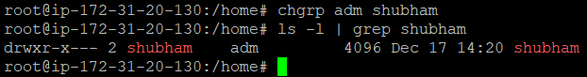

* Created a folder called data and changed the ownership and group using the command **chown <owner> : <group> folder**.
* Changed file permission of data by setting **SGID (chmod 2775 data)** so that any file/folder created inside data have the same group ownership as the parent folder.

